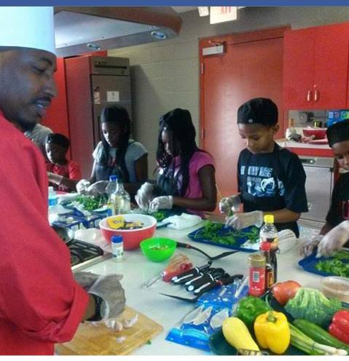 **FREE CLASSES! SIGN UP SOON!**

**May 22nd 10am-Noon ⃝**

**May 22nd Noon-2pm ⃝**

**June 11th 9am-11:30am ⃝**

**Please select (1) class.**

**Registration Form (Print Only)**

Child’s Name: ______________________________________________________________________

Gender: _________ Grade:_________ Age:_____________

Parent’s Signature of Consent:_______________________________________#_________________

Emergency Contact: ______________________________________________#__________________

Email: ____________________________________________________________________________

**Quick questionnaire:**

**Does your child have any food allergies?** *(Common food allergies include peanuts, chocolate, wheat, eggs, and other items.)*

**Environmental allergies?** *(We don’t want you inhaling powdered spices if you are sensitive to dusts or powders.)*

**Vegetarian?**

**Does your child eat pork? Beef? Chicken?**

**Fish, shellfish?**

**Any medical conditions we should know about for the purpose of this class?** *(Hypertension, low-sodium, high-cholesterol, seizures, etc.) or N/A.*

**Anything, kitchen related that you would like to share about your child that may be helpful to this course, please share.**

* ____________________________________________________________________________________________________________________________________________________________________________

**Please include the Areas of interest that your child shows?**

* **Worldly Cuisines (Caribbean, French, Mexican, Thai, Chinese, American, etc)**
* **Flavors, Spices**
* **Creating new dishes from scratch**
* ____________________________
* ____________________________

**(FAQ)**

* **I have a food allergy. Can I still take your cooking classes?**

Absolutely! We will do whatever we can to accommodate food sensitivities and allergies.

* **Do I need to bring anything?**

We provide knives, chef hats, & aprons, but ask that you wear comfortable, closed-toe shoes for your safety. You might find it useful to bring your own reusable containers, to take home some of the delicious foods you will cook in class.

* **How should I dress for a class?**

Remember that all kitchens get hot, so it is best to dress in layers for classes. You will be more comfortable if you can remove a jacket when the room starts warming up.

* **Where do I park?**

FREE Parking is conveniently located next door in the Decatur Library parking deck.

* **Can I buy a gift card for cooking classes?**

Yes, Gift Cards are available starting at $25. Redeemable for Future classes, Personal Chef Services, Catering Services, and Apparel.

* **Do you offer special parties for groups?**

We love parties! And we can help you arrange fun events that will be remembered for a lifetime.

Thanks for cooking with Chef Q! If you have any questions or concerns, please feel free to contact me at [chefquentinboswell@yahoo.com](mailto:chefquentinboswell@yahoo.com) or (678) 379-9942

Thank you,

**Chef Quentin Boswell**